*A PROJECT REPORT*

FIELD EMPLOYEE MANAGEMENT SYSTEM

*Submitted by*

**PRAJAKTA KARANDIKAR (12BCER012)**

**DHVANISH PATEL (12BCER024)**

**VIGNEET SOMPURA (12BCER053)**

*In partial fulfillment for the award of the degree*

*of*

*BACHELOR OF TECHNOLOGY*

*in*

*COMPUTER ENGINEERING*



**INDUS INSTITUTE OF TECHNOLOGY AND ENGINEERING**

**INDUS UNIVERSITY,**

**RANCHARDA via-THALTEJ,**

**AHMEDABAD-382115**

JUNE-2016

**PROJECT REPORT**

ON

FIELD EMPLOYEE MANAGEMENT SYSTEM

FOR



In the partial fulfillment of the requirement

For the degree of

Bachelor of Technology in Computer Engineering

**Prepared by**

|  |
| --- |
| PRAJAKTA KARANDIKAR (12BCER012)  DHVANISH PATEL (12BCER024)  VIGNEET SOMPURA (12BCER053) |
|  |

**Under guidance of**

|  |  |  |
| --- | --- | --- |
|  |  | **Internal Guide** |
|  |  | MAITRIK SHAH  (IITE CE DEPT.) |

**Submitted to**

|  |
| --- |
| INDUS Institute of Technology & ENGINEERING |
| INDUS University  rancharda Via- thaltej  ahmedabad - 382115 |

jUNE-2016

**CANDIDATE’S DECLARATION**

We declare that final semester report entitled “FIELD EMPLOYEE MANAGEMENT SYSTEM” is our own work conducted under the supervision of the guide Prof Maitrik Shah.

We further declare that to the best of our knowledge this report does not contain part of the work which has been submitted earlier for the same either in this or any other university without proper citation.

Candidate’s Signature

PRAJAKTA KARANDIKAR

DHVANISH PATEL

VIGNEET SOMPURA

Prof. Maitrik Shah

Internal Guide

Department of Computer Engineering

Indus Institute of Technology & Engineering

Ahmedabad,

State: Gujarat

## **INDUS INSTITUTE OF TECHNOLOGY AND ENGINEERING**

**COMPUTER ENGINEERING**

**2015-16**

### new logo

**CERTIFICATE**

**Date**:15-04-2016

### This is to certify that the project work entitled “**FIELD EMPLOYEE MANAGEMENT SYSTEM**” has been carried out by **PRAJAKTA KARANDIKAR, DHVANISH PATEL, VIGNEET SOMPURA** under my guidance in partial fulfillment of degree of Bachelor of Technology in **COMPUTER ENGINEERING (Final Year)** of Indus University, Ahmedabad during the academic year 2015-16.

___________________________ ________________________________

MAITRIK SHAH BHOOMI TRIVEDI

Assistant Professor, Head of the Department

Department of Computer Engineering, Department of Computer Engineering,

I.I.T.E, Indus University I.I.T.E, Indus University

Ahmedabad Ahmedabad

Acknowledgement

Towards the successful completion of our B.Tech. in Computer Engineering final year project for MacGray Solutions, we feel greatly obliged to Prof Maitrik Shah and Prof. Jignesh Patel.

We have no other words to express our sincere thanks to all faculties of Indus University, Ahmedabad for their kind co-operation and able guidance especially to Prof. Maitrik Shah, our internal project guide in college without whom the project could not be executed.

* Prajakta Karandikar

Dhvanish Patel

Vigneet Sompura

**Table Of Content**

**Title Page No**

**ABSTRACT………………………………………………………… i**

**LIST OF FIGURES………………………………………………... ii**

**LIST OF TABLES…………………………………………………. iv**

**ABBREVIATIONS………………………………………………… iv**

**CHAPTER 1 INTRODUCTION………………………………….. 1**

1.1 Project Summary…………………………………….. 2

1.2 Project Purpose………………………………………. 2 1.3 Project Scope………………………………………… 3

1.3.1 Context………………………………………. 3

1.3.2 Information Objectives………………………. 4

1.3.3 Function and Performance…………………… 4

1.4 Objectives……………………………………………. 4

1.4.1 Main Objectives……………………………... 4

1.4.2 Secondary Objectives……………………….. 5

1.5 Technology and Literature Review……………......... 5

1.6 Synopsis……………………………………………... 6

**CHAPTER 2 PROJECT MANAGEMENT…………………….. 7**

2.1 Project Planning …………..……………………….. 8

* + 1. Software Scope…………………………….. 8
    2. Resource…………………………………… 8
       1. Human Resource…………………... 9
       2. Reusable Software Resources……... 9
       3. Environment Resource…………….. 9
    3. Project Development Approach………….. 9
  1. Project Scheduling……………………………….... 11
     1. Basic Principal…………………………….. 11
     2. Compartmentalization ………………….… 11
     3. Work breakdown structure………………… 12
     4. Project Organization……………………..... 12
     5. TimeLine Chart……………………………. 13
        1. Time Allocation…………………… 13
        2. Task Sets…………………………... 13

**CHAPTER 3 SYSTEM REQUIREMENTS……………………. 16**

* 1. User Characteristics…………………………...…… 17
  2. Functional Requirement………………...…………. 17
     1. Admin Module…………………………….. 17
     2. Employee Module…………………………. 18
  3. Non Functional Requirement…………………… 18
  4. Hardware and Software Requirement………….. 19
     1. Hardware Requirement…………………. 19
     2. Software Requirement …………………. 20
     3. Server Hosting Requirement……………. 20

**CHAPTER 4 SYSTEM ANALYSIS…………………………. 21**

* 1. Study of Current System……………………….. 22
  2. Problems in Current System……………………. 22
  3. Proposed New System………..…………….…… 23
  4. Feasibility Study………………….………..…… 23
     1. Technical Feasibility……………………. 23
     2. Economical Feasibility …………………. 24

**CHAPTER 5 DETAIL DISCRIPTION…………………..…… 25**

* 1. Admin Module…………………………………… 26
  2. Employee Module………………………………… 32
  3. Data Dictionary………………………………. 34

**CHAPTER 6 SYSTEM DESIGN…………………..………… 40**

* 1. Class Diagram………………………..………… 41
  2. Use – Case Diagram………………….………… 42
  3. Sequence Diagram…………………………….. 43
  4. Activity Diagram………………………………… 46
  5. Data Flow Diagram……………………………… 51

**CHAPTER 7 LIMITATION AND FUTURE ENHANCEMENT… 54**

* 1. Limitation…………………………………………. 55

7.2 Future Enhancement……………………………… 55

**CHAPTER 8 CONCLUSION………………………………… 56**

8.1 Conclusion………………………………………… 57

**BIBLIOGRAPHY……………………………………………………. 58**

ABSTRACT

This report presents a practical implementation of an on-field employee guidance and management system. Managing field employees can be tough especially if no organized technique or system is in place. This report explains all the advantages of the said system, the variety of management tasks that can be performed and also the features of employee guidance module for proper and timely completion of the scheduled tasks.

This report serves to analyze the “Field Employee Management System” which shall be known as “The System” henceforth, for its purpose, functionalities, system design, system analysis and its limitations. Its unique features and future scope are pointed out.

The Administrator user holds powers to take up new clients, schedule and reschedule tasks based on given parameters, keep a track of employees’ locations, monitor the expenses, approve images of old machine parts for genuineness and also view the status of the scheduled tasks. On the other hand, Employee user can use the system as a guidance software- Viewing task date-time-place, navigational help to the client address, uploading images and viewing lists of complete and incomplete tasks.

The practical applicability of the system goes beyond goal of timely task completion. It helps brings structure and organization in the company’s field-work arena. A comprehensively designed database is in support of well-informed task scheduling and task monitoring and also gives the scope for report creation. Analysis of User-System interaction and Class/Data-Flow/Activity/Sequence diagrams shed more light on the working of the system from various prospects. This system maintains the chain of command and facilitates smooth working of the field work arena.

List Of Figures

|  |  |  |
| --- | --- | --- |
| **Figure No** | **Title** | **Page No.** |
| Figure 2.1 | Project Resource Pyramid | 8 |
| Figure 2.2 | Prototyping Model | 10 |
| Figure 2.3 | Work Breakdown Structure | 12 |
| Figure 2.4 | Project Organization | 13 |
| Figure 6.1.1 | Class Diagram | 41 |
| Figure 6.2.1 | Use-Case Diagram for Admin Module | 42 |
| Figure 6.2.2 | Use-Case Diagram for Employee Module | 42 |
| Figure 6.3.1 | Sequence Diagram for Admin Module | 43 |
| Figure 6.3.2 | Sequence Diagram for Employee Verification | 44 |
| Figure 6.3.3 | Sequence Diagram for Employee Module | 45 |
| Figure 6.4.1 | Activity Diagram for Admin Authentication | 46 |
| Figure 6.4.2 | Activity Diagram for Home Page (Admin Module) | 46 |
| Figure 6.4.3 | Activity Diagram for Locate Employee | 47 |
| Figure 6.4.4 | Activity Diagram for Add Task | 47 |
| Figure 6.4.5 | Activity Diagram for Employee Page | 48 |
| Figure 6.4.6 | Activity Diagram for Employee Module | 49 |
| Figure 6.4.7 | Activity Diagram for Navigation Bar | 50 |
| Figure 6.4.8 | Activity Diagram for Employee Registration | 50 |
| Figure 6.5.1 | DFD Level-0 | 51 |
| Figure 6.5.2 | DFD Level-1 | 51 |
| Figure 6.5.3 | DFD Level-2 for Admin Module | 52 |
| Figure 6.5.4 | DFD Level-2 for Employee Module | 53 |

List of Tables

|  |  |  |
| --- | --- | --- |
| **Table No** | **Title** | **Page No.** |
| Table 1.1 | Synopsis | 6 |
| Table 2.1 | Time Line Chart | 15 |

ABBREVIATION

Abbreviations used throughout this whole document for the application are:

HTML Hypertext Markup Language

CSS Cascading Style Sheet

JSP Java Server Pages

XML eXtensible Markup Language

SQL Structured Query Language

AJAX Asynchronous Javscript And XML

API Application Programming Interface

GUI Graphical User Interface

UI User Interface

WWW World Wide Web

RAM Random Access Memory

SSE2 Streaming SIMD Extension 2

JVM Java Virtual Machine

JRE Java Runtime Environment

JDK Java Development Kit

IMEI International Mobile Equipment Identity

DFD Data Flow Diagram

**Chapter 1**

**Introduction**

* **PROJECT SUMMARY**
* **PURPOSE**
* **SCOPE**
* **OBJECTIVE**
* **TECHNOLOGY REVIEW**
* **SYNOPSIS**

1.1 PROJECT SUMMERY

Field Employee Management System, as the name suggests, is an efficient system to have organized dealings with the company’s on-field employees. The system consists of two modules- administrator module and employee module.

The administrator module gives the administrator power to carry out a variety of management related tasks. Tasks such as to take up new clients, schedule and reschedule tasks based on given parameters, keep a track of employees’ locations, monitor the expenses, approve images of old machine parts for genuineness and also view the status of the scheduled tasks. The employee module is for proper and timely completion of the scheduled tasks on the employee side. Employee user can use the system as a guidance software- Viewing task date-time-place, navigational help to the client address, uploading images and viewing lists of complete and incomplete tasks.

The System can be accessed by the administrator user through a website on which the admin user can log in using their identification and password. Each of the field employees must carry a GPS enabled android mobile device with a working data plan. The employees can thus access the system through an Android Application.

1.2 PURPOSE

The purpose of the project to simplify the management of field work for MacGray solutions Pvt. Ltd. The owner of the company is close acquaintance and narrated the issues faced while managing the work of multiple field employees, at the same time, spread out over multiple nearby cities, simply on calls. The developed system would bring structure and organization in managing the field-work. The System would afford complete transparency to the administrator/manager regarding the scheduled tasks, location of field-working employee, status of tasks and many other aspects.

The System serves the purpose of a mediator between Admin-Employee and leaves no scope for miscommunication or negligence. The Administrator can, at all times, know the exact position of the scheduled tasks and also view information about those tasks that have been completed or cancelled.

1.3 PROJECT SCOPE

In order to develop a reasonable project plan, we must first determine the scope of the project undertaken. We must draw the line of the Project Scope considering available resources including funds and time. It is imperative to follow software engineering principles. The project management activity is the determination of software scopes. By considering the following objectives of software scopes, we derived the System scope statements.

* Software must be easy to understand, easy to use.
* Must reflect all important information clearly.

Software scope is defined by Activity context, information objectives, function and performance.

* + 1. **CONTEXT**

Field Employee Management System is a Java based Task Manager-Guidance System. It greatly simplifies the mechanism of handling employees and their respective tasks whilst monitoring their allowances. The System will maximize the productivity and coherence of both manager and employees greatly. It can be expanded further on into a bigger project to incorporate larger population of employees. It is an ideal system with the right balance between simplicity and features.

* + 1. **INFORMATION OBJECTIVES**

The source of all task related information for the system is the administrator. He/She shall take orders from existing customers or take up new customers. All this information shall be entered and managed by the administrator through the Website medium. This information shall be saved on an online server via the website and shall remain in records for two months. This information will be available to the concerned employee who will be responsible for the completion of the specified task. An employee can only see all the information of the tasks allotted to him. This he shall view via the Android application in his phone. He can view information of the past month and the current month.

**1.3.3 FUNCTION & PERFORMANCE**

Main function of website is to store the task based on availability of the employee and view the status and other task related information. Main function of the android application is to view upcoming task information and view navigation to the customer address and change the status of the task according to the success of task completion.

The system must make the work of coordination easy on both the ends. This is done effectively by the clarity of design and ease of use.

1.4 OBJECTIVES

**1.4.1 MAIN OBJECTIVE**

Project’s main objective is to simplify the management of field work for MacGray solutions Pvt. Ltd. To bring structure and organization in managing the field-work. The System would afford complete transparency to the administrator/manager regarding the scheduled tasks, location of field-working employee, status of tasks and many other aspects.

**1.4.2 SECONDARY OBJECTIVES**

* The employee can view his own account information.
* He can directly contact the customers via email, phone.
* He can get directions to the site of service through the android application.

1.5. TECHNOLOGY AND LITERATURE REVIEW

* LANGUAGES
  + JAVA: Java is a general purpose, high level programming language that is object oriented, class-based and specifically designed to have as few dependencies as possible.
* JAVA TECHNOLOGIES
  + JSP: It stands for Java Server Pages. It is a server side programming technology that helps to create dynamically generated web pages based on HTML, XML or other document types. It controls the content or appearance of Web pages through the use of servlets, small programs that are specified in the Web page and run on the Web server to modify the Web page before it is sent to the user who requested it.
* WEB TECHNOLOGIES
  + HTML/CSS: HTML is a mark-up language for describing web pages. It stands for Hyper Text Mark-up Language. It contains a set of tags that are used to generate components of a website. CSS stands for Cascading Style Sheets.CSS describes how HTML elements are to be displayed on screen. It controls layout of multiple web pages at once.
  + JQUERY: JQuery is a java script library which greatly simplifies java script programming.
* MOBILE TECHNOLOGIES
  + ANDROID: It is an open source operating system generally used in mobile phones and tablets. According to current user base and device cost, it is most feasible to develop system for this platform.
* DATABASE
  + MySQL: It is most widely used, open source database. It is very popular and easy to use.
* OTHER TECHNOLOGIES
  + AJAX: It stands for Asynchronous JavaScript and XML. It is a [client-side script](http://www.seguetech.com/blog/2013/02/07/what-are-the-pros-and-cons-of-client-side-scripting) that communicates to and from a server/database without the need for a [post back](http://www.c-sharpcorner.com/uploadfile/2f73dd/what-is-postback-in-Asp-Net/) or a complete page refresh. It exchanges data with a server and updating the parts of a web-page without reloading the entire page.
  + GOOGLE MAPS API: It is used for integration of google maps into our system.

1.6 SYNOPSIS

|  |  |
| --- | --- |
| **Project title** | Field Employee Management System |
| **Project description** | Create Website and Android Application for Management of MacGray Solutions field-work to co-ordinate with the Android Application for guidance of employees along with 2-month storage of Task information on an online server. |
| **Objective** | To make a System with Website for Manager and Android Application for Employees for proper field- work management. |
| **Purpose** | To simplify the field work management for MacGray solutions. |
| **Name of company** | MacGray Solutions Pvt. Ltd. |
| **Anticipated outcome** | Coordinated System of Website to manage tasks and Android Application to guide the execution of tasks. |
| **Time frame** | 11:00 a.m. to 4 p.m., Weekdays 8th Semester |
| **Time Duration** | Approximately 4 Months |
| **Software specification** | Windows, JAVA, MySQL |
| **Address of Company** | C-806, Ganesh Meridian, Sola, Ahmedabad. |

**Chapter 2**

**Project Management**

* **PROJECT PLANNING**
* **PROJECT SCHEDULING**

2.1 PROJECT PLANNING

The objective of software project planning is to provide a framework that enables the project manager to make reasonable estimates, cost, and scheduling. These estimates are made within a limited time frame at the beginning of a software project and should be updated regularly as the project progresses.

The project is developed MacGray Solutions Pvt. Ltd, Ahmedabad in time duration for completing the project is from 16th Jan, 2016 to 20th May, 2016.

During the project development period we have submitted report to the internal guide on regular intervals weekly. Also we have held meetings with the company manager to update him and get his feedback regarding the work in progress.

There are many issues in the software project planning as follows:

**2.1.1 SOFTWARE SCOPE**

Project planning should be done in a manner such that maximum resources can be availed on time.

Function and performance allocated to software during system engineering should be assessed to establish a project scope that is unambiguous and understandable at the management and technical levels.

**2.1.2 RESOURCES**

People

Reusable software

Components

***Hardware and Software tool***

**Figure 2.1: Project Resource Pyramid**

The second software planning task is to estimation of the resources required to accomplish the software development effort. The above figure illustrates development resources as a pyramid. The development environment – hardware and software tools-sits at the foundation of the resources pyramid and provide the infrastructure to support the development effort. At a higher level, we encounter reusable software components-software building blocks that can dramatically reduce development costs and accelerate delivery. At the top of the pyramid the primary resource-people.

* + - 1. **HUMAN RESOURCES**

The human resources required are

1. Database, network administrator.
2. Project Guides.
   * + 1. **REUSABLE SOFTWARE RESOURCE**

Reusability is possible as and when require in this application. We can update it when new customer/employee registers or when there is any modification of data. Reusable software reduces design, coding and testing cost by amortizing effort over several designs. All other software components are built as per the need.

**2.1.2.3. ENVIRONMENT RESOURCE**

The environment that supports the software project, often called the software engineering includes software and hardware.

**2.1.3. PROJECT DEVELOPMENT APPROACH**

To solve actual problems in industry settings, software engineer or a team of engineers must incorporate development strategy that encompasses the process, methods and tools layers and generic phases. This strategy is often referred to as process model or an engineering paradigm. A process model for software engineering is chosen based on the nature of the project and application, the methods and tools to be used and the controls and deliverables that are required. Even outside the industry setting, the selection of proper product development method is imperative.

We have followed Prototype Model Approach to develop the Field Employee Management System.

Customer evaluation

Design

Build prototype

Refine requirements incorporating customer suggestions

Design

Requirement gathering

Coding

Test

Maintain

Accepted by customer

**Figure 2.2: Prototyping Model**

2.2 PROJECT SCHEDULING

* Project scheduling is one of the main key aspects of any project. Any project must have a precise schedule before developing it.
* When project developer works on scheduled project it is more advantageous for him/her to compare to unscheduled project. It gives us timeline for finishing the particular activity. Scheduling gives us idea about project length, its cost, its expected duration of completion and we can also find out the shortest way to complete the project with less overall cost of project.
* Project schedule describes dependency between activities. It states the estimated time required to reach each milestones and allocation of people to activities.

**2.2.1 BASIC PRINCIPAL**

“Software project scheduling is an activity that distributes estimated effort across the planned project duration by allocating the effort to specific software engineering tasks.”

**Proper scheduling requires:**

* All tasks appear in network and dependent on some of other.
* Effort and timing are intelligently allocated to each task.
* Interdependencies between tasks are properly indicated.
* Resources are allocated for the work to be done.
  + 1. **COMPARTMENTALIZATION**

Our software project is compartmentalized into the following tasks,

* Designing the GUI using HTML and CSS
* JQuery for designed pages
* Adding Back-End Processes
* Validations.
* Testing.
  + 1. **WORK BREAKDOWN STRUCTURE**

It is used to decompose a given task and set recursively in small task.

Field Employee Management System

Requirement Specification

Design

Coding

Testing

Documentation

Graphical User Interface Part

Graphical User Interface Part

**Figure 2.3: Work breakdown structure**

* + 1. **PROJECT ORGANIZATION**

This describes the way in which the development team is organized the people involved and their roles in team. Here Project Organization Chart is shown.

Client

(MacGray Solutions Pvt. Ltd.)

Project Guide

(Mr. Maitrik Shah)

Project Developers

(Prajakta Karandikar)

(Dhvanish Patel)

(Vigneet Sompura)

**Figure 2.4: Project Organization**

**2.2.5 TIMELINE CHART**

**2.2.5.1 TIME ALLOCATION**

Each task to be scheduled must be allocated some number of work units.

**2.2.5.2 TASK SETS**

We have selected the “Prototype Process Model” so that there are six different work tasks to work together. A tasks set is a collection of software engineering work tasks, milestones, and deliverables that must be accomplished to complete a particular project. Tasks set are designed to accommodate different types of projects..

Most software organizations encounter the following projects.

* Concept Development.
* New Applications development.
* Applications enhancement.
* Applications maintenance.
* Re-engineering project.

###### Refinement of major tasks

The above tasks are again refined as follows:

* Analysis of required system

1. Study of required flow
2. Study of methodology

* Defining goals and objectives

**1.**  Preparing the goal

**2.**  Defining the flow of the project

* Finding out resources required

**1.** Identifying the resources

**2.** Making arrangement for getting the resources

* Coding and Testing.

**1.** Designing the tables and creating them.

**2**. Coding for the Website, Application.

**3.** Validation of the forms.

**5.** Testing

* Documentation

**1.** Divide document in small parts

**2**. Documentation of each part

**3.** Integration of all parts

**4.** Review of project documentation.

|  |  |  |  |  |  |
| --- | --- | --- | --- | --- | --- |
| ID | Task | Start | Finish | Days | Comments |
| 1 | Project Analysis | 16th Jan 2016 | 9th Feb 2016 | 24 | - |
| 2 | UI Design | 9th Feb 2016 | 12th Feb 2016 | 3 | - |
| 3 | Database Design | 12th Feb 2016 | 16th Feb 2016 | 4 | - |
| 4 | UI implementation | 16th Feb 2016 | 23rd Feb 2016 | 6 | (Admin Module) |
| 5 | Back-End implementation | 23rd Feb 2016 | 26th Apr 2016 | 63 | (Admin Module) |
| 6 | UI implementation | 16th Feb 2016 | 23rd Mar 2016 | 36 | (Employee Module) |
| 7 | Back-End implementation | 15th Mar 2016 | 7th May 2016 | 51 | (Employee Module) |

Table 2.1: Time Line Chart

**Chapter 3**

**System Requirement**

* **USER CHARACTERISTICS**
* **FUNCTIONAL REQUIREMENT**
* **NONFUNCTIONAL REQUIREMENT**
* **SOFTWARE AND HARDWARE SCOPE**

3.1 USER CHARACTERISTICS

The user of the system must have following characteristics

* Admin
  + The user must have basic knowledge of Computer Devices.
  + The user should understand the use of all modules.
  + The user should be able to easily interact with the proposed system.
* Employee
  + The user must have basic knowledge of Android Devices.
  + The user should understand the user interactions of employee module which include inserting data for the current task, uploading relevant images, contacting the customer.
  + The user must allow location services to provide the location to the server.
  + The user should travel by the path suggested by the system if possible.

3.2 FUNCTIONAL REQUIREMENT

* + 1. **ADMIN MODULE**

The Basic activities involved in the system are:

* View Tasks
* Approve Tasks
* Filter Tasks by Date/Employee/Task Type/Status.
* Track Employee
* View Employee Details
* Filter Employee by Name/ Contact Number
* Add Employee
* Add Customer
* Add Task
  + 1. **EMPLOYEE MODULE**

The Basic activities involved in the system are:

* Authenticate Employee
* View Current Tasks
* View Finished Tasks
* View Cancelled Tasks
* View Tasks on Selected Date
* View Task Details
* Contact Customer (Call/Message/Email)
* Get directions to the address of the Customer
* Start Task
* Notify Employee After 30 mins
* Update Task Related Info. (Meter Readings/Payment Collection/Part Replaced/Work done)
* Upload Images for Meter Reading/Part Replacement/Food Bills/Travel Bills
* Cancel Task

3.3 NONFUNCTIONAL REQUIREMENT

There are lots of features that we have included in the software. But some of them were described over here.

* **Easy to maintain records:**

All the records are stored in the database that can be accessed by both Web application and Android Application.

* **Available on WWW:**

The website can be seen on the browser anytime and can be accessed anytime by secure login connection.

* **Robustness:**

On failure to access the internet, no changes required by the user must be committed either using the android application or web application.

* **Ease of Use:**

The design of the system must be unambiguous enough for the user to understand the proper functionality of the system.

* **Minimal Data Usage:**

Android application being totally based over the mobile internet should use the least amount of data as possible.

3.4 SOFWARE AND HARDWARE SPECIFICATION

Hardware and Software Requirements are used to describe the minimum hardware and software requirements to run the Software. These requirements are described below.

**3.4.1 HARDWARE REQUIREMENT**

* **ADMIN MODULE**
* Intel Pentium 4 or later that’s SSE2 capable
* RAM: 1GB+
* Internet Connection (512 Kbps/ 1Mbps recommended)
* **EMPLOYEE MODULE**
* Android Device
* Processor 1GHz+
* RAM: 1GB+
* Camera: 2MP+
* Internet Connection (3G Recommended)
  + 1. **SOFTWARE REQUIREMENT**
* **ADMIN MODULE**
* Windows 7 or higher
* Any Web Browser (Recommended Google Chrome)
* **ADMIN MODULE**
* Android 4.1 (Jelly Bean) or higher
  + 1. **SERVER HOSTING REQUIREMENT**
* MySQL Database
* Hosting JSP, Servlet pages
* Apache Tomcat 5
* JVM, JRE, JDK 1.6

**Chapter 4**

**System Analysis**

* **STUDY OF CURRENT SYSTEM**
* **PROBLEMS IN CURRENT SYSTEM**
* **PROPOSED NEW SYSTEM**
* **FEASIBILITY STUDY**

4.1 STUDY OF CURRENT SYSTEM

Currently, MacGray works in an old fashioned way. A customer calls to the company head, requests for some service. Then the head contacts the employee and gives details of the task. The Employee reports back to the company head after finishing the task. All this information needs to be stored manually using files and folders for future review.

4.2 PROBLEM AND WEAKNESSES OF THE CURRENT SYSTEM

* The storage system is unstructured and in paper format. Thus, probability of loss of data is high.
* The employee has to remember each and every task assigned to him/her. For this, he has to note down the details of the task somewhere.
* The employee also has to report back to the head about the task so he needs to keep a record of that too.
* Company head has to remember the schedule of employees so that he can assign new tasks to them.
* In this system, the chances of human error are high which can result in failure of a task.
* The employee may not be able to work at his full potential due to the additional burden of remembering too many details about tasks.

4.3 PROPOSED NEW SYSTEM

In our proposed system we have developed a Website and an Android application for company head and employees respectively. The company head will now have to assign task through a website. The details will be automatically reflected in the application. Thus, the need of remembering all the details for a task are eliminated. Employees can report back to the company head directly from the application by entering the details of completed task. The company head can view all the task assigned and filter them according to his need. Also, the company head can keep a track of his employee location as the android application keeps updating its location to the server. Thus, due to our new proposed system the probability of losing data and human error are reduced to a very large extent which increases the efficiency and working potential of both employees and the company head.

4.4 FEASIBILITY STUDY

**4.4.1 TECHNICAL FEASIBILITY**

* Our website is designed using HTML/CSS and Polymer libraries which provide User Interface according to material guidelines offered by Google.
* Polymer components are light weight and provide pre-defined APIs for Google Maps, AJAX requests, and validations.
* The backend developed in JAVA(JSP) provide database interaction for both the website and android application. JSP provides multithreading and background processing smoothly.

**4.4.2 ECONOMICAL FEASIBILITY**

* All the technologies used are open source and freely available thus eliminating the licensing cost.
* Web hosting, domain space, and Internet Packs are the only expenses that the company needs to pay to run this application.

**Chapter 5**

**Detail Description**

* **Administrator Module**
* **Employee Module**
* **Data Dictionary**

5.1 ADMINISTRATOR MODULE

* **LOGIN**:

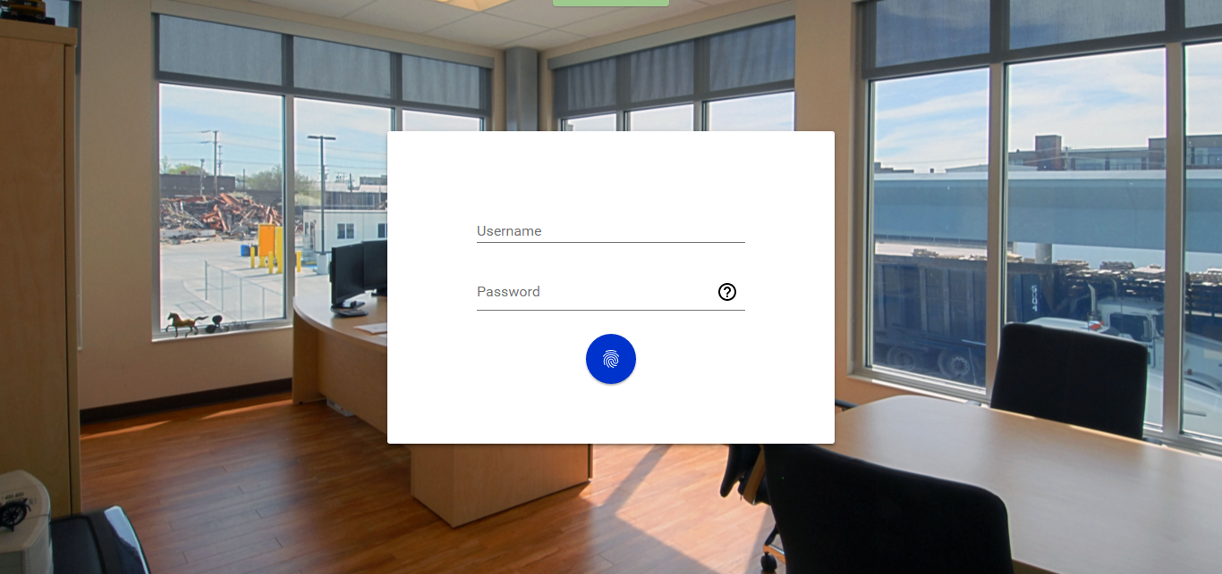It is the index page of our website. As the website is not for regular users, so the authentication is required for viewing the website.

**Figure 5.1.1: Login Page**

* **TASKS:**

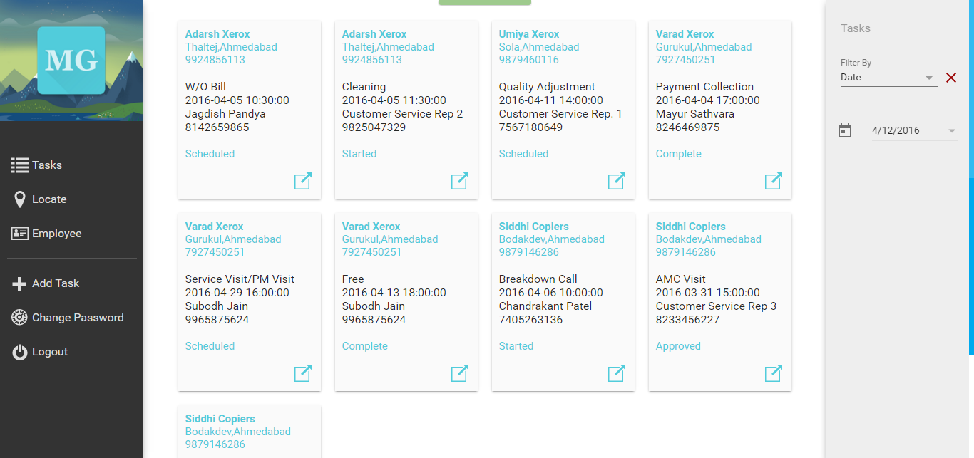Initially, this page displays the tasks of current date in card layout that can be expanded to display detailed description. Admin can update the status of the task from the pop-up after approval of uploaded images.

**Figure 5.1.2: Tasks page**

* + 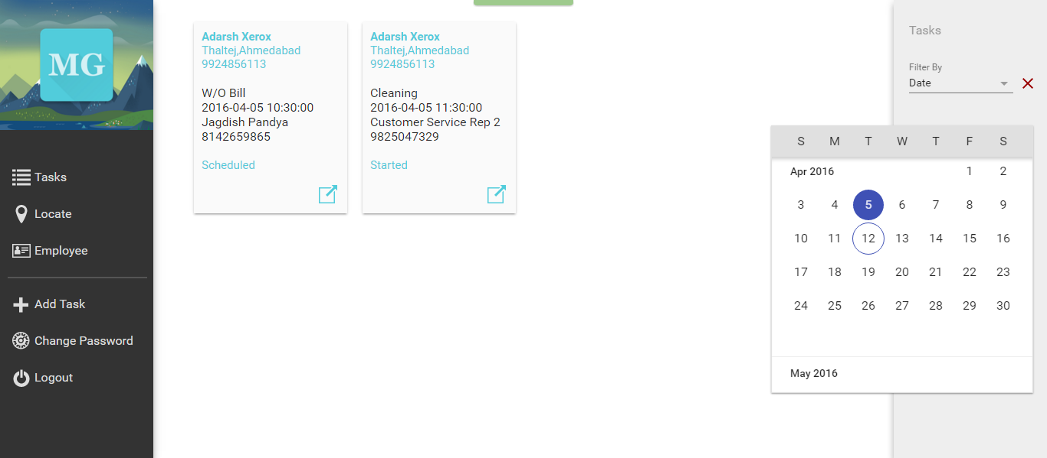FILTER TASK: Admin can filter task according to date, employee, task type and status.

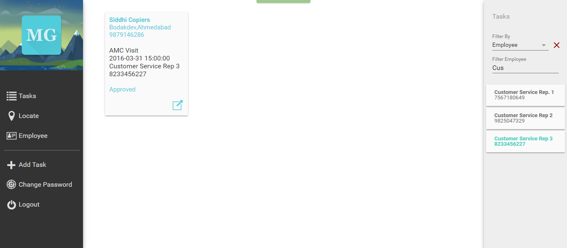**Figure 5.1.3: Filter Tasks by Date.**

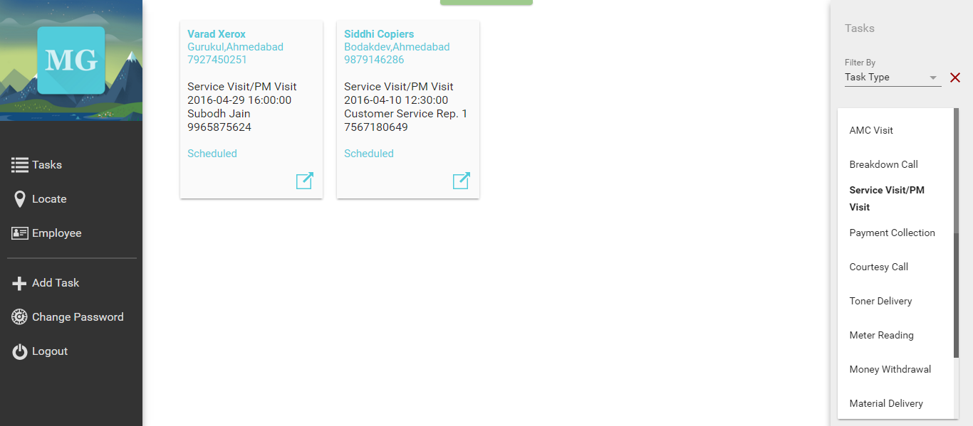**Figure 5.1.4: Filter Tasks by Employee**

**Figure 5.1.5: Filter Tasks by Task Type**

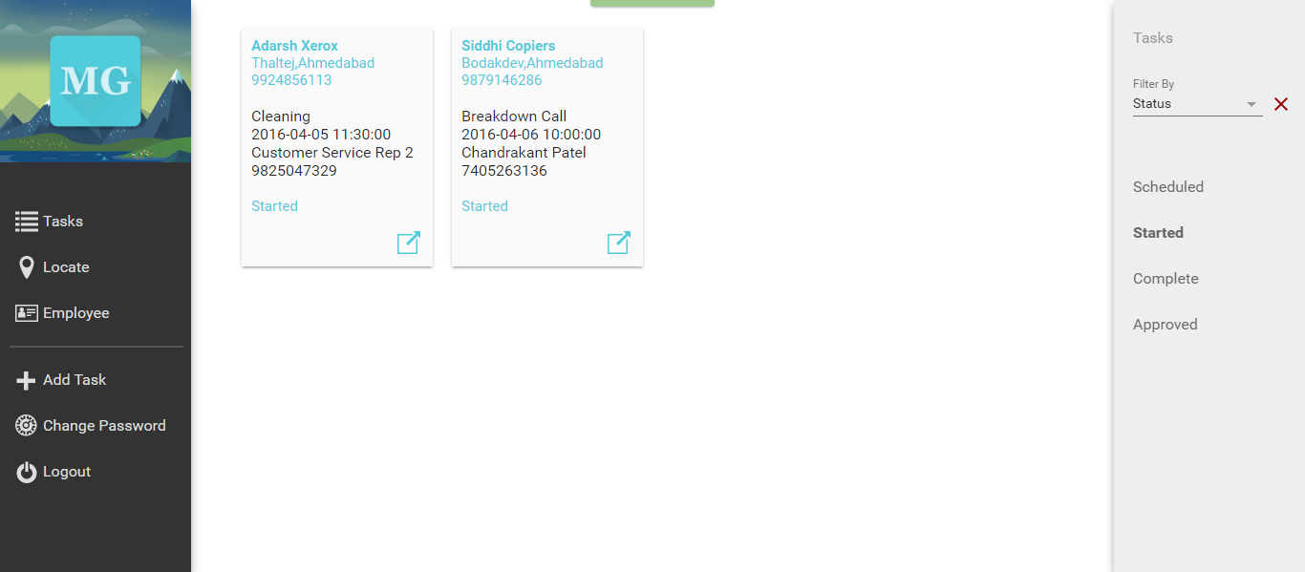

**Figure 5.1.6: Filter Tasks by Status**

* **LOCATE:**

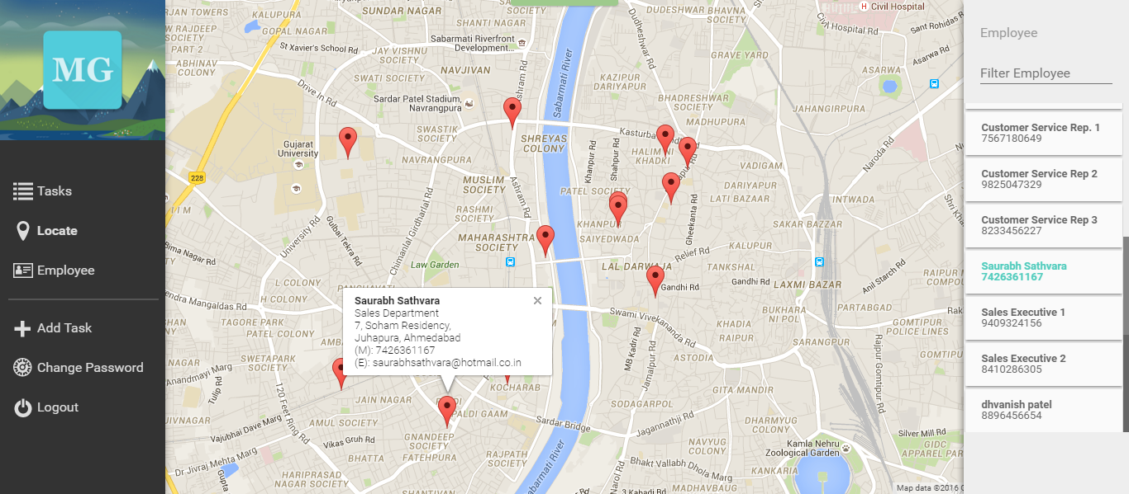This page displays the current location of all employees. Markers of all employees are refreshed every 60 seconds. Admin can search for a particular employee and view his location.

**Figure 5.1.7: Locate Employee Screen**

* **EMPLOYEE:**

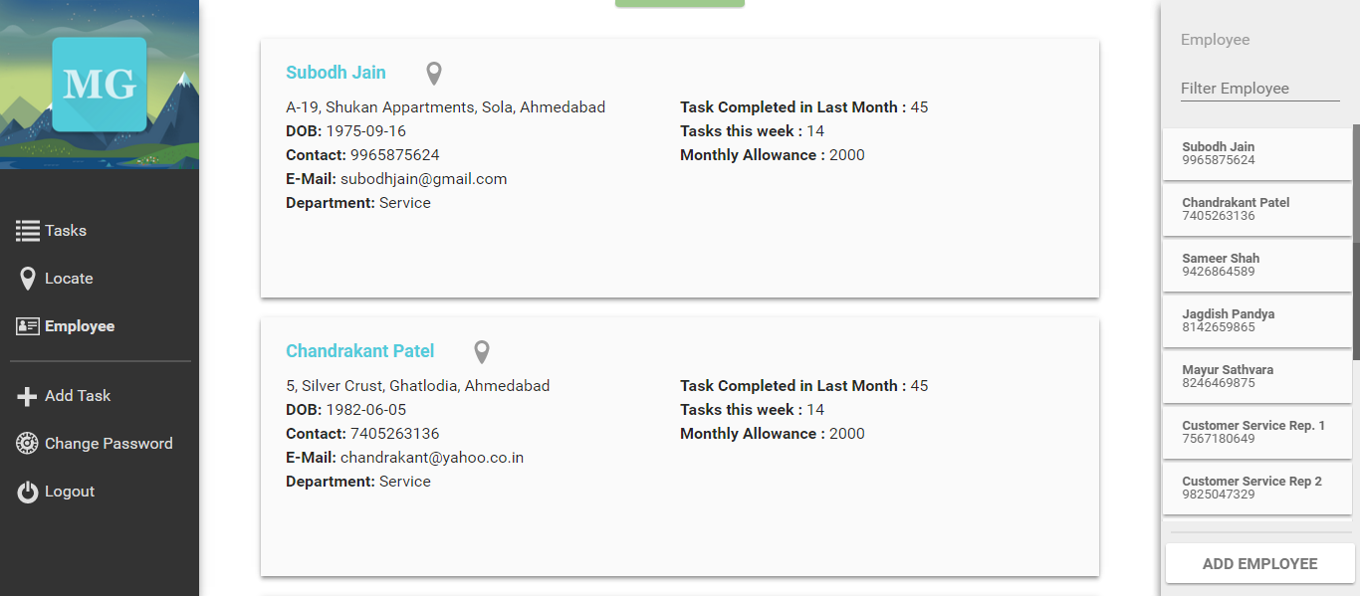A detailed information of all employees is listed on this page. Admin can select a particular employee to view his/her details and also find his/her location.

**Figure 5.1.8: Employee Information Page**

* + ADD EMPLOYEE: Newly hired employee can be added to the system with this menu.

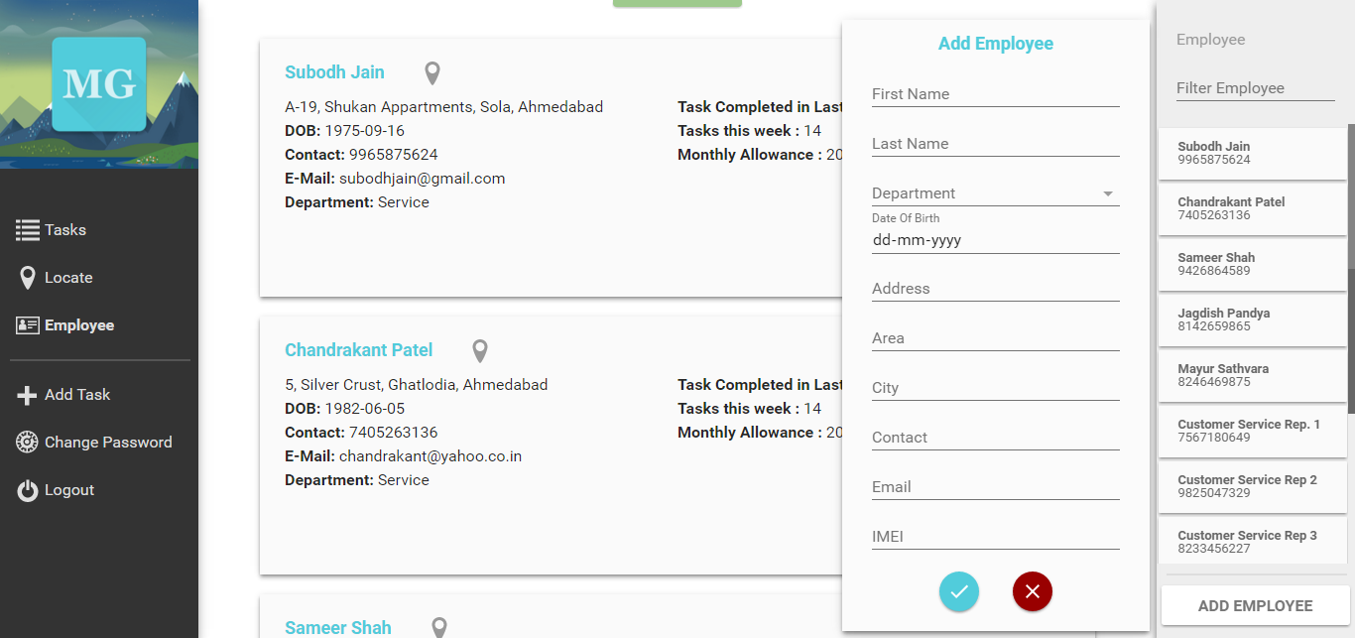

**Figure 5.1.9: Add Employee Dialog**

* **ADD TASK:**

Clicking this will open a side menu no matter what page you are on that will allow admin to assign new tasks easily according to the availability of his employees.

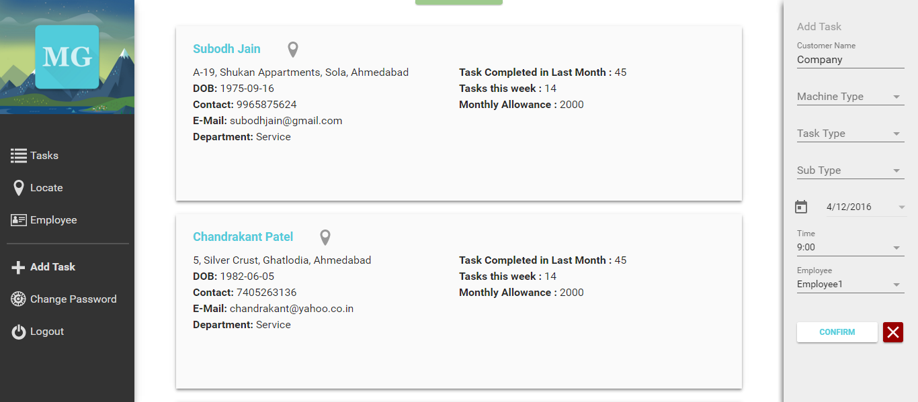

**Figure 5.1.10: Add Task Menu**

* + 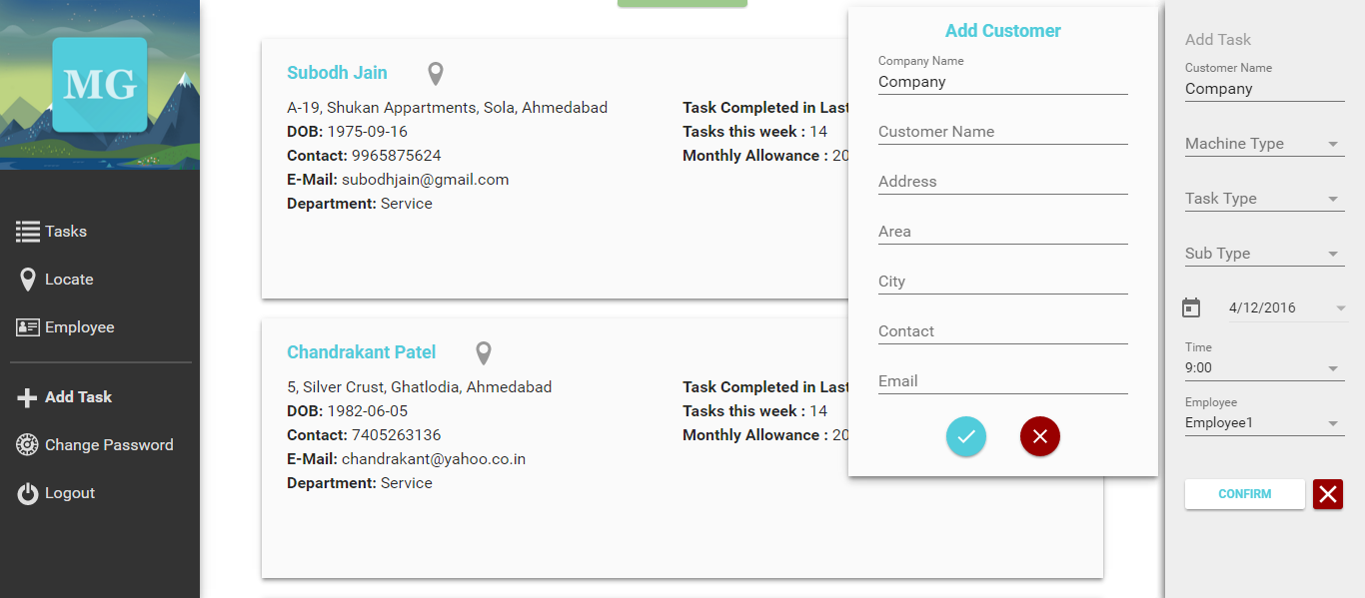ADD CUSTOMER: In the case of a new customer, admin can add them directly from this menu with another side menu that will be opened asking for details of the new customer.

**Figure 5.1.11: Add Customer Dialog**

* **CHANGE PASSWORD:**

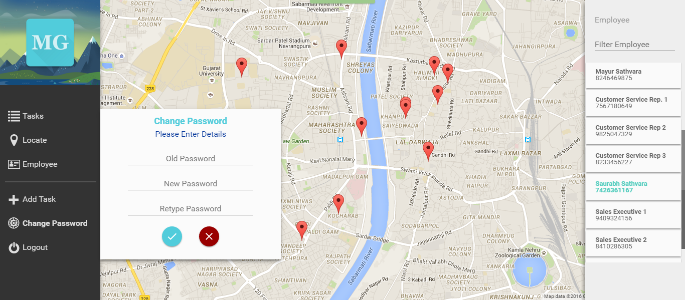For a secure system changing the password regularly is recommended. This page fulfills that requirement.

**Figure 5.1.12: Change Password Dialog**

* **LOGOUT:**

Closing the system so others cannot access it without proper credentials.

5.2 EMPLOYEE MODULE

* **IDENTITY VERIFICATION**

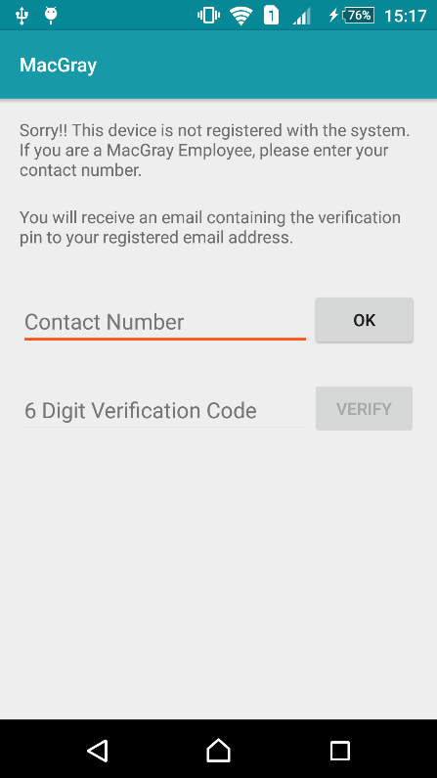When the application is started, the IMEI number of the device is verified against existing database. If the IMEI number does not exist in the database, the user will be prompted to enter the contact number. This contact number will be verified against the entry in the database. If the contact number is valid it will store the new IMEI and redirect to the home screen of the application else, it will show an error.

* **CURRENT TASKS**

It shows the list of task to be performed on that particular day. Tasks displayed are in a list view and shows customer name, task type and scheduled time. Details of the task can be viewed by clicking it.

* + TASK DETAILS:

Shows the details of the task in a new fragment.

* + 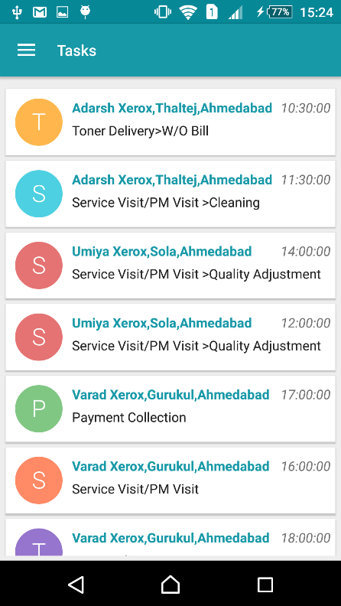CONTACT CUSTOMER:

From task details fragment, the employee has the facility to call, message or email the customer.

* + DIRECTION TO CUSTOMERS ADDRESS:

The employee is able to view direction to customer’s address from his current location.

* + START/CANCEL TASK:

When the employee is in task details screen or maps screen he will have these two options available. When start task is selected it will redirect to a new screen where task details can be updated accordingly by the employee and timer will be started which will notify him after 30 mins to complete the task as early as possible. On selecting cancel task, the employee will be prompted to enter reasons for cancelling the task.

* + UPDATE TASK DETAILS:

This screen will be opened when an employee has started a particular task. It will allow him to enter various details of task such as meter reading, payment collection, etc. The employee will also have the option to provide details of the task he did and can add some comments if needed.

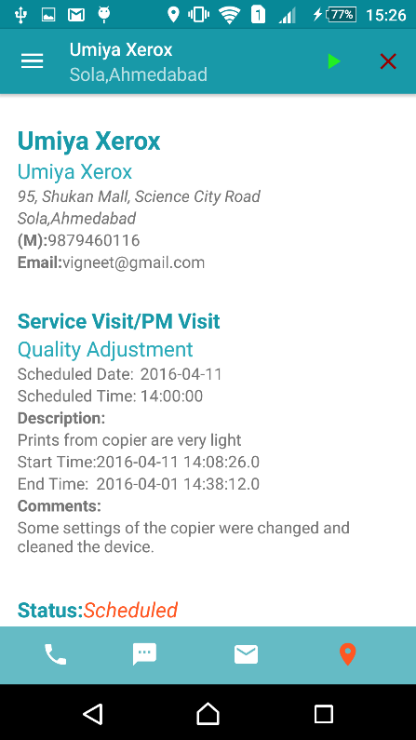 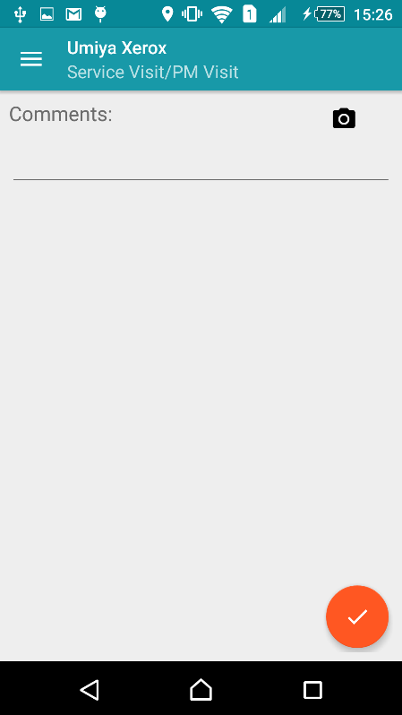

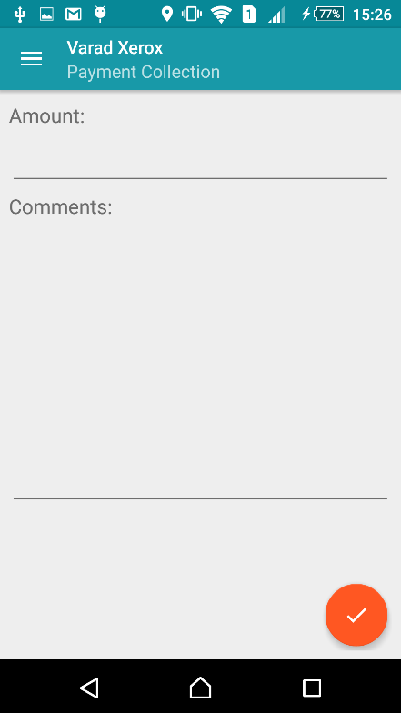 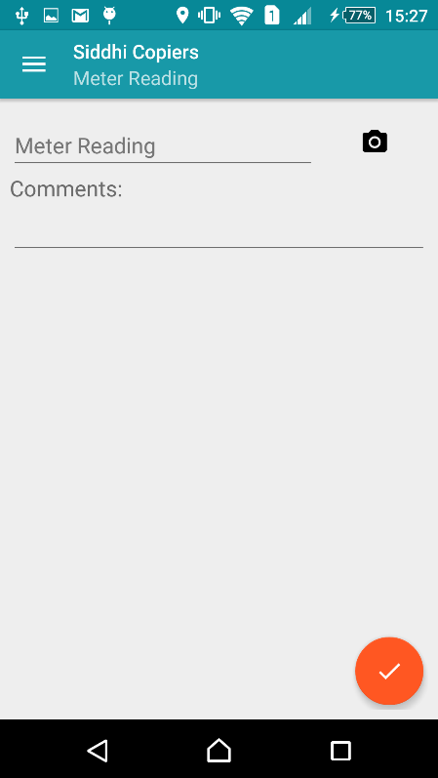

* + UPLOAD IMAGES:

This functionality will be used by the employee to upload relevant images of the task which will be later approved by the administrator.

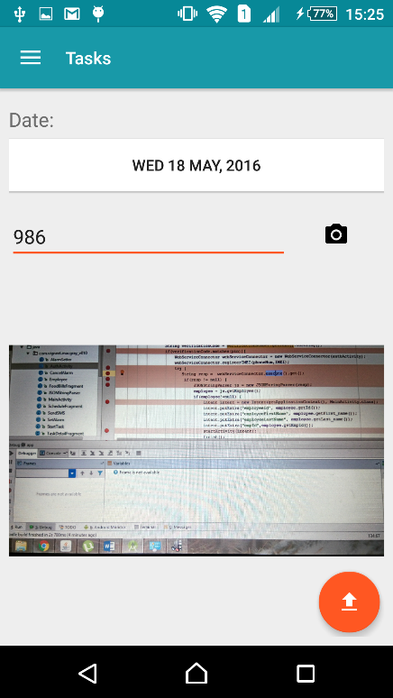 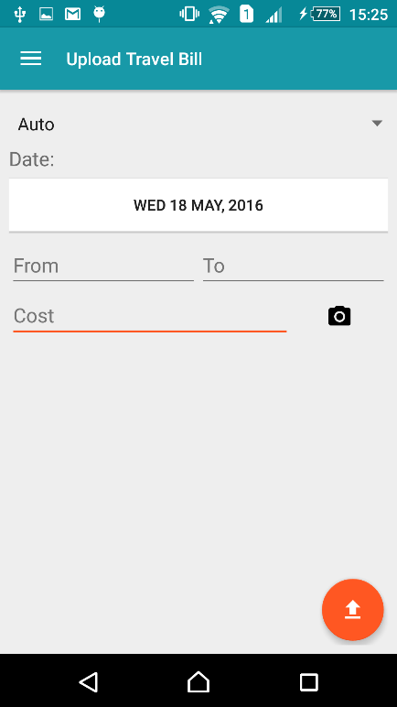

* + END TASK:

Once the task is started by the employee and all the required details are entered, this button will be active. When this button is pressed the timer will stop and the entered details will be updated in the database.

* **COMPLETED TASKS**

This screen shows the list of completed task of last 2 months. It will be a list view same as current tasks screen and details of that task can be viewed by clicking it.

* **CANCELLED TASKS**

This screen shows the cancelled task of last few months. The layout of this screen will also be same as that of current tasks and details will be available on clicking it.

* **SCHEDULE**

This option will allow the employee to see all the task by selecting a particular date from the calendar.

* **ACCOUNT INFORMATION**

This screen shows employee his own statistics such as total task performed in last month, average daily task completed, his allowance, etc.

* **LOCATION SERVICE**

This application needs to have access to the location services. This service will be running in the background during employee working hours and will continuously update the location of an employee in the database.

5.3 DATA DICTIONARY

**customers**

|  |  |  |  |  |
| --- | --- | --- | --- | --- |
| Column | Type | Null | Default | Comments |
| customer_id | int(11) | No |  |  |
| company_name | varchar (255) | No |  |  |
| customer_name | varchar (255) | No |  |  |
| Address | Text | No |  |  |
| Area | varchar (255) | No |  |  |
| City | varchar(255) | No |  |  |
| Contact | bigint(10) | No |  |  |
| Email | Text | Yes | *NULL* |  |
| Long | Double | Yes | *NULL* |  |
| Lat | Double | Yes | *NULL* |  |

**Indexes**

|  |  |  |  |  |  |  |  |
| --- | --- | --- | --- | --- | --- | --- | --- |
| Keyname | Type | Unique | Packed | Column | Cardinality | Collation | Null |
| PRIMARY | BTREE | Yes | No | customer_id | 7 | A | No |

**employees**

|  |  |  |  |  |
| --- | --- | --- | --- | --- |
| Column | Type | Null | Default | Comments |
| employee_id | int(11) | No |  |  |
| first_name | varchar(255) | No |  |  |
| last_name | varchar(255) | No |  |  |
| Dob | Date | No |  |  |
| department | varchar(255) | No |  |  |
| Address | Text | No |  |  |
| Area | varchar(255) | No |  |  |
| City | varchar(255) | No |  |  |
| Contact | bigint(10) | No |  |  |
| Email | varchar(255) | No |  |  |
| lat | Double | Yes | 23.03 |  |
| long | Double | Yes | 72.58 |  |
| average | int(11) | Yes | *NULL* |  |
| imei | bigint(15) | Yes | *NULL* |  |
| PIN | Int(6) | Yes | *NULL* |  |

**Indexes**

|  |  |  |  |  |  |  |  |
| --- | --- | --- | --- | --- | --- | --- | --- |
| Keyname | Type | Unique | Packed | Column | Cardinality | Collation | Null |
| PRIMARY | BTREE | Yes | No | employee_id | 11 | A | No |
| Contact | BTREE | Yes | No | contact | 11 | A | No |
| email | 11 | A | No |
| imei | 11 | A | Yes |
| Imei | BTREE | No | No | imei | 11 | A | Yes |

**food_cost**

|  |  |  |  |  |
| --- | --- | --- | --- | --- |
| Column | Type | Null | Default | Comments |
| food_bill_id | int(11) | No |  |  |
| employee_id | int(11) | No |  |  |
| Date | date | No |  |  |
| Cost | int(11) | No |  |  |
| URL | text | Yes | *NULL* |  |
| approval_status | varchar(255) | No | not approved |  |

**Indexes**

|  |  |  |  |  |  |  |  |
| --- | --- | --- | --- | --- | --- | --- | --- |
| Keyname | Type | Unique | Packed | Column | Cardinality | Collation | Null |
| PRIMARY | BTREE | Yes | No | food_bill_id | 0 | A | No |
| employee_id | BTREE | No | No | employee_id | 0 | A | No |

**locations**

|  |  |  |  |  |
| --- | --- | --- | --- | --- |
| Column | Type | Null | Default | Comments |
| employee_id | bigint(15) | No |  |  |
| Time | timestamp | No | CURRENT_TIMESTAMP |  |
| Long | Double | No |  |  |
| Lat | Double | No |  |  |

**Indexes**

|  |  |  |  |  |  |  |  |
| --- | --- | --- | --- | --- | --- | --- | --- |
| Keyname | Type | Unique | Packed | Column | Cardinality | Collation | Null |
| PRIMARY | BTREE | Yes | No | employee_id | 0 | A | No |
| time | 0 | A | No |

**task_types**

|  |  |  |  |  |
| --- | --- | --- | --- | --- |
| Column | Type | Null | Default | Comments |
| task_type_id | int(11) | No |  |  |
| Name | varchar(255) | Yes | *NULL* |  |
| parent_id | int(11) | Yes | 0 |  |
| machine_type | varchar(255) | No | Copier |  |

**Indexes**

|  |  |  |  |  |  |  |  |
| --- | --- | --- | --- | --- | --- | --- | --- |
| Keyname | Type | Unique | Packed | Column | Cardinality | Collation | Null |
| PRIMARY | BTREE | Yes | No | task_type_id | 28 | A | No |
| parent_id | BTREE | No | No | parent_id | 14 | A | Yes |

**tasks**

|  |  |  |  |  |
| --- | --- | --- | --- | --- |
| Column | Type | Null | Default | Comments |
| task_id | int(11) | No |  |  |
| employee_id | int(11) | No |  |  |
| customer_id | int(11) | No |  |  |
| task_type_id | int(11) | No |  |  |
| payment_collected | int(11) | Yes | *NULL* |  |
| description | text | Yes | *NULL* |  |
| scheduled_date | date | No |  |  |
| scheduled_time | time | No |  |  |
| start_time | timestamp | Yes | *NULL* |  |
| end_time | timestamp | Yes | *NULL* |  |
| comments | text | Yes | *NULL* |  |
| Status | varchar(255) | No | Scheduled |  |
| Reading | Int(11) | Yes | *NULL* |  |
| URL | text | Yes | *NULL* |  |

**Indexes**

|  |  |  |  |  |  |  |  |
| --- | --- | --- | --- | --- | --- | --- | --- |
| Keyname | Type | Unique | Packed | Column | Cardinality | Collation | Null |
| PRIMARY | BTREE | Yes | No | task_id | 8 | A | No |
| employee_id | BTREE | No | No | employee_id | 8 | A | No |
| customer_id | 8 | A | No |
| task_type_id | 8 | A | No |
| customer_id | BTREE | No | No | customer_id | 8 | A | No |
| tasktype_id | BTREE | No | No | task_type_id | 8 | A | No |

**travel_cost**

|  |  |  |  |  |
| --- | --- | --- | --- | --- |
| Column | Type | Null | Default | Comments |
| travel_id | int(11) | No |  |  |
| employee_id | int(11) | No |  |  |
| Date | date | No |  |  |
| mode_of_transport | varchar(255) | No |  |  |
| from | varchar(255) | No |  |  |
| to | varchar(255) | No |  |  |
| cost | int(11) | No |  |  |
| URL | text | Yes | *NULL* |  |
| approval_staus | varchar(255) | No | not approved |  |

**Indexes**

|  |  |  |  |  |  |  |  |
| --- | --- | --- | --- | --- | --- | --- | --- |
| Keyname | Type | Unique | Packed | Column | Cardinality | Collation | Null |
| PRIMARY | BTREE | Yes | No | travel_id | 0 | A | No |
| employee_id | BTREE | No | No | employee_id | 0 | A | No |

**users**

|  |  |  |  |  |
| --- | --- | --- | --- | --- |
| Column | Type | Null | Default | Comments |
| username | varchar(255) | No |  |  |
| Password | text | No |  |  |
| Email | text | No |  |  |

**Indexes**

|  |  |  |  |  |  |  |  |
| --- | --- | --- | --- | --- | --- | --- | --- |
| Keyname | Type | Unique | Packed | Column | Cardinality | Collation | Null |
| PRIMARY | BTREE | Yes | No | username | 0 | A | No |

[](http://localhost/phpmyadmin/db_datadict.php?db=macgray2.0&table=users&server=1&target=&token=3f90715b79e51e850c1cc82fa7154424)

**Chapter 6**

**System Design**

* **CLASS DIAGRAM**
* **USECASE DIAGRAM**
* **SEQUENCE DIAGRAM**
* **ACTIVITY DIAGRAM**
* **DATA FLOW DIAGRAM**

6.1 Class Diagrams



**Figure 6.1.1 : Class Diagram**

6.2 Use Case Diagrams



**Figure 6.2.1: Use Case Diagram for Administrator Module**



**Figure 6.2.2: Use Case Diagram for Employee Module**

6.3 Sequence Diagrams

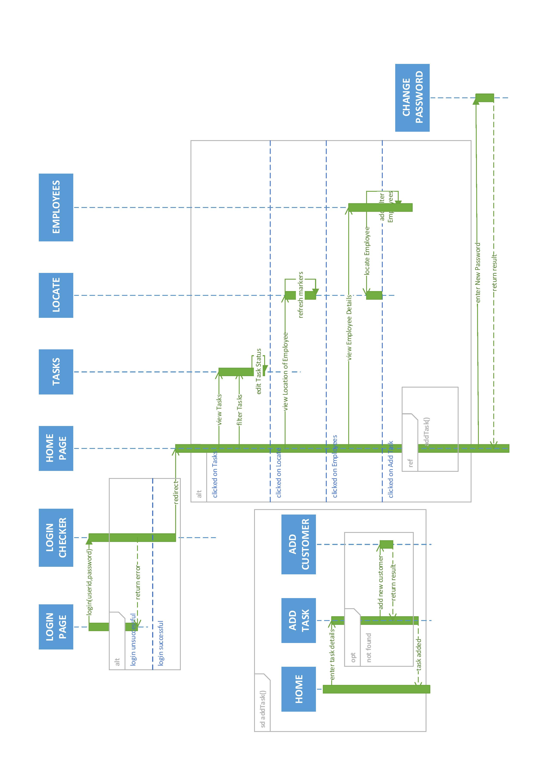

**Figure 6.3.1: Sequence Diagram For Administrator Module**



**Figure 6.3.2: Sequence Diagram for Employee Verification**

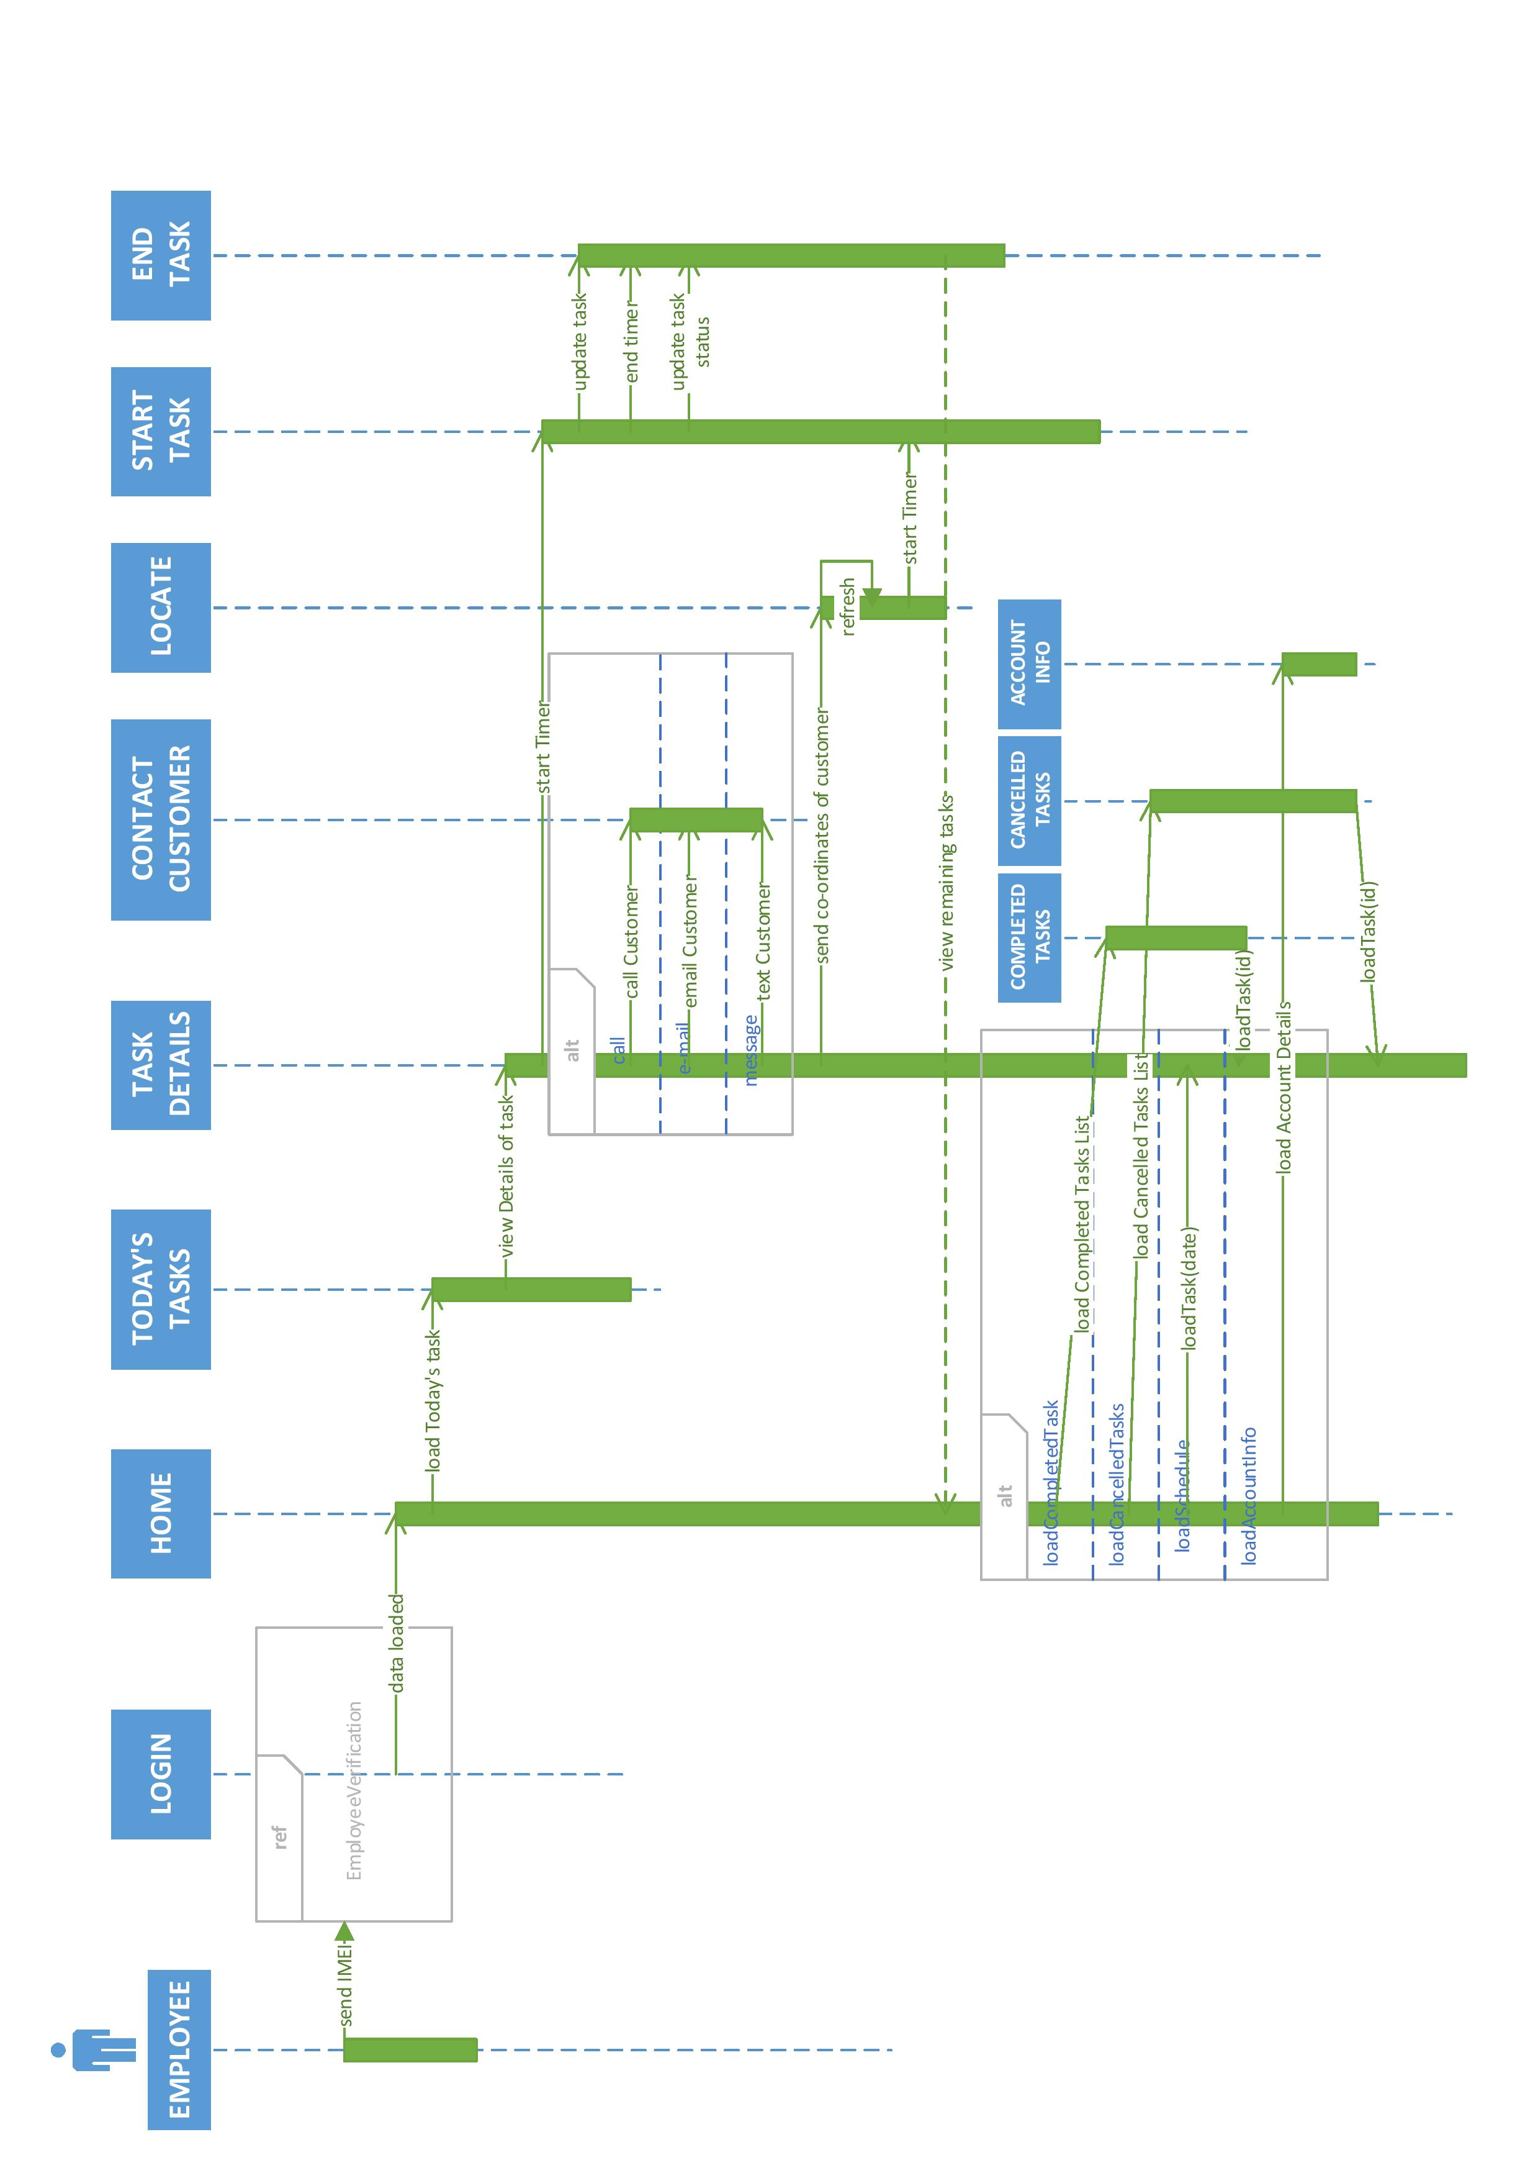

**Figure 6.3.3: Sequence Diagram for Employee Module**

6.4 Activity Diagrams



**Figure 6.4.1: Activity Diagram for Admin Authentication**



**Figure 6.4.2: Activity Diagram for Home Page (Admin Module)**



**Figure 6.4.3 : Activity Diagram for Locate Employee**



**Figure 6.4.4: Activity Diagram for Add Task**



**Figure 6.4.5: Activity Diagram for Employees Page**



**Figure 6.4.6: Activity Diagram for Employee Module**



**Figure 6.4.7: Activity Diagram for Navigation Bar**



**Figure 6.4.8 : Activity Diagram for Employee Registration**

6.5 Data Flow Diagrams



**Figure 6.5.1: DFD Level-0**



**Figure 6.5.2: DFD Level-1**



**Figure 6.5.3 DFD Level-2 for Admin Module**



**Figure 6.5.4: DFD Level-2 for Employee Module**

**Chapter 7**

**Limitations and Future Enhancements**

* **LIMITATIONS**
* **FUTURE ENHANCEMENTS**

**7.1 LIMITATIONS**

* No System Access in case of lack of network connectivity.
* Android Application supported only by phones having android version jellybean or higher.
* Employee might need battery backup for working longer durations.
* Android Marshmallow devices can turn off “location” services for a specific application. If there is loss of location information, the administrator can’t determine the cause to be deliberate or loss of network connectivity.
* Administrator must assign all tasks to an employee manually.
* Customer must contact the admin each time he needs to request a service/ update task/ revoke request.

**7.2 FUTURE ENHANCEMENTS**

* Viewing Reports created as per month, employee and customer.
* Foreseeing predictable tasks such as yearly service, monthly visit for cartridge replacement etc. for a given customer.
* Forms for updating/deletion of customer/employee.
* Applying and admin- granting of employee leave requests.
* Customer module can eliminate the need for admin to manually assign tasks to employees. The step can be circumvented, saving time and effort on part of the admin.

**Chapter 8**

**Conclusion**

**8.1 CONCLUSION**

The Field Employee Management System simplifies the operation of field-work for any organization with a field service wing. The entire work pattern from both the administrator end and employee end have been “computerized” so to speak. It guides the admin while making task scheduling decisions, maintenance of employee or customer information, gives a complete picture of the on-field work carried out and employee location by the minute. It shows the employee the list of tasks to be carried out and also guides the employee to the customer site. It even registers the start-stop time for each task. Everything is taken care of. As of a current scenario, the work in this sphere is disorganized and takes a toll on the memories of those involved. All the task information needs to be memorized or manually written down. We have reviewed why the use of system is necessary. We have looked at the activities that are involved in field management and incorporated the same in it.

It is important to fulfil the user characteristics and hardware and software requirements to use the system to an advantage.

Bibliography

<http://www.tutorialspoint.com/uml/uml_class_diagram.htm>

<https://en.wikipedia.org/wiki/Class_diagram>

<http://www.tutorialspoint.com/uml/uml_use_case_diagram.htm>

<https://sourcemaking.com/uml/modeling-business-systems/external-view/activity-diagrams>

<http://www.tracemodeler.com/articles/a_quick_introduction_to_uml_sequence_diagrams/>

<http://www.slideshare.net/mohit4192/dfd-examples>